Derby Association of Community Partners
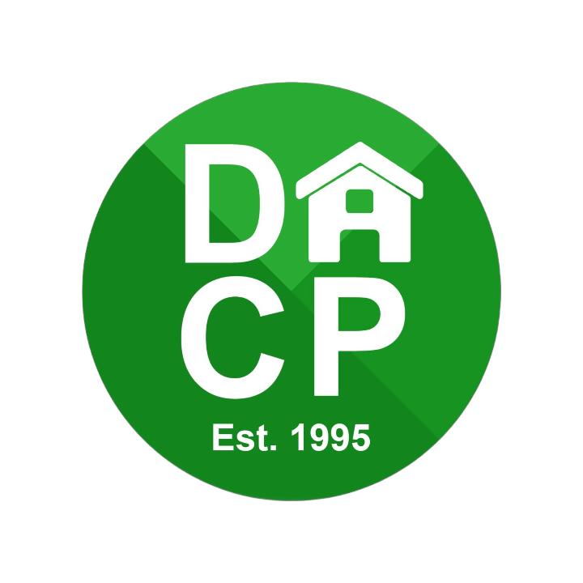

2025 - 2026 Application Pack



DACP APPLICATION FORM



FUNDING APPLICATION GUIDANCE NOTES:

Before proceeding with your application please read, and keep these notes and the Terms and Conditions

In the 2025/2026 financial year, the DACP will continue to support community groups across Derby City

This year, the DACP is thrilled to offer £20,000 in funding to support a variety of groups across Derby.
The theme for this year is: Growing communities
DACP has a proud history of backing the brilliant community groups, projects, and organisations that make a real difference in people’s lives. This funding is all about helping those who support our communities.
If your group has a great idea or project that fits the theme, this could be your chance to bring it to life!
Application Deadline: Sunday 31 August 2025
Who can apply?
To apply for a grant from DACP you must be a community group, a voluntary or not for profit organisation, or a local resident delivering a project/service in Derby City that benefits the local community and Derby Homes tenants.

This year the DACP are largely focused on supporting smaller grassroots groups.

What can we fund?
You can apply for a grant to fund a project or initiative that aims to benefit the local community. The following is an idea of the items that are covered, but not limited to:

- Small, grassroots clubs
- Equipment or materials, such as fishing tackle, outdoor games, arts & crafts, or cooking equipment
- Start-up funds – sowing the seed to create a new project or initiative
- Lunch or Social clubs aiming to cover the cost of FREE lunches, activities or special celebrations
- Activities for carers, such as days out or social activities
- Garden projects, to cover the cost of equipment, plants or seating
- Training programs – building skills and knowledge to grow

Please be aware that we will not fund the building of new premises, or the repair or maintenance of an existing property/building. If your request is for food support, it may be directed to other local services such as Derby Food 4 Thought Alliance.

How much can I apply for?

As we only fund smaller projects, the standard funding limit is capped at £1,000. We encourage all applicants to apply for the full amount

In exceptional circumstances, the DACP has discretion to award funding of up to £2,000.

Application process

We ask anyone wishing to apply for a grant from DACP to complete the Application Form and send it to:

DACP Ltd
PO Box 8652
Derby
DE1 9RY

Or by email to: thedacp95@gmail.com

Once received, your application will be checked to ensure it is fully completed before it is considered by the members of DACP. It will then be subject to a final approval by Derby Homes.

Please be aware that this process can take up to three months before a grant is paid. It is therefore vital that you send your application in good time. You are reminded that monies spent, or items purchased prior to approval cannot be included in your final grant.

The applicant may be contacted for further information or be invited to a meeting to provide a short presentation about their project. This is not mandatory but could help answer any questions that the DACP have and will help to ensure the application is considered in a timely manner.

Depending on the nature of your project we may visit to see how it is working. We may also take photographs for our own publicity. Any photographs of service users that are taken will only be published with full consent of the individuals concerned and permission obtained under the requirements of the GDPR.

Once your project is complete, we may ask you to attend another DACP meeting to provide feedback on how the project went, how the funding helped and to show us some photos etc (if applicable) so we can learn from the projects we support.

Application Form

NB: Before completing this application, please read the included terms and conditions. Completion will be taken as confirmation that the applicant has read and understood the conditions and requirements.

Organisation details
Name of your organisation or group

Type of organisation / group
(i.e., registered charity, Community or Voluntary Group, School, Other statutory body, Individual, Limited Company etc.)

Please state your company or charity number (if applicable)

What area of Derby City do you operate within?
(Any requests for funding outside of this area will not be approved)

Please tell us about how you approach safeguarding and equality.

Applicant details
Title | Forename | Surname
Position within organisation
Contact details
Full address

Email
Phone number
Bank Details
To help us ensure a smooth process, please provide bank details we can use to send payment if your application is approved. This section is optional — if you prefer, we can contact you for this information after the deadline.
Account holder's name
Sort Code
Account number

Application Details
Organisation Background
Describe the background and purpose of your organisation/group. Please include links to website and/or social media pages as evidence.

How will this funding be used?

DACP funding is supported by Derby Homes. How does your project align with and support Derby Homes’ customers or their mission?
You can find more information about Derby Homes’ delivery plan for Derby on their website (here)

How do you know there is a need/want for your project or activity?
Please include details of any research or consultation you have carried out

What is the date when your project will be completed. If you are purchasing items,
tell us when this is likely to be.
If funding is needed before the expected funding release (October 2025), your application will likely be denied.

What impact do you expect this funding to have?

In your opinion, how does your project relate to this year’s theme of “Growing Communities”?
I.e., sustainability, long term growth, fresh and new initiatives etc

Funding Breakdown

If your application is successful, how would you spend the DACP funding.

We encourage you to use the full £1000 funding. Please tell us how much DACP funding you are requesting in a full breakdown and show any other funding or resources you are using to pay for the project.

No: | Activity or item | Cost per activity or item (£) | Amount of DACP Budget requested (£) | Other funding.  List funder and amount (£) | Total Project Cost (£)
1

2
3
TOTAL
If more space is required, please add extra cells to table, or attach a separate sheet.

What other funding has your organisation received in the past 24 months.
Name of funding body | Amount received | Purpose for funding

Before you sign the application form, please check that you have completed all the questions and have read and understood the terms and conditions as seen below.

This application should be signed by the applicant named above, and any attachments will be considered as part of your application. Please also sign and date the Data Protection Notice below.

Name

Position in organisation

Signed | Date

Data Protection Notice

DACP Limited is registered as a data processor with the Information Commissioner - ref: C1185470

Data Protection legislation and the GDPR allows DACP Limited to reasonably use personal information contained within this application for the prevention of fraud. This includes the exchange of information with other relevant organisations and any supporting documents and notes from discussions and meetings relevant to the application.

DACP Limited agrees that all personal data collected will only be used for processing and validating this application and will be deleted. Information relating to successful applications will be securely retained for six-years under UK financial regulations. Declined applications will be retained for one year unless retention is required for legal reasons.

Please tick, and date, this box to confirm that you agree to this notice and accept that DACP Limited will use and discuss your personal data whilst processing and validating your application.

I hereby agree to these conditions: |  | Tick box to confirm.

Signed: Date:

Please send your completed application form to:

DACP Ltd
PO Box 8652
Derby
DE1 9RY

Or by email to: thedacp95@gmail.com

If you have any questions please call 07543 775948 between 10.30am to 4.30pm, Monday, Wednesday and Friday – voicemail available outside of these times.

TERMS AND CONDITIONS

Before signing the application form it is important that you have read and understand the following terms and conditions. By signing your application, you are agreeing to the terms and conditions listed below.

If your application is successful, you will be awarded funding based on this agreement.

- Any grant money must be used for the purposes set out in the application. No changes to the project, or how the grant is to be spent, may be made without the prior agreement of the DACP.

- The DACP will not pay grant funding for expenditure incurred before the project approval date.

- The funded project must not sell or dispose of any equipment, or other assets purchased with the grant, without the prior knowledge and written consent of the DACP.

- The applicant must make sure that the project is value for money and will keep a record of all quotations, estimates and receipts of items purchased.

- Funds must be held in a bank/building society account in the name of the project, or an account of an approved organisation that will be responsible for overseeing the project. Grant funding will not be paid into a personal account.

- Where the grant is to be used to pay an employed staff member, or members, this must be declared on the application. If any person named within the application is to receive a wage as part of the project their name and role must be included within the application.

- The applicant must ensure that the project complies with any relevant legislation affecting its delivery.

- The applicant will make sure that anyone involved in the funded project is kept safe by:

  - having its own safeguarding policies in place that are appropriate for the work of the project and providing a copy to DACP prior to approval.

  - ensuring compliance with Derby Homes and DACP Health & Safety policies.

  - ensuring that any volunteers involved in regulated activities with children and young people have completed the appropriate level of DBS (Disclosure and Barring Service) check.

  - ensuring that the premises in which the project or service is to be delivered are fit for purpose.

  - providing child protection, safeguarding and health and safety training and guidance for staff and volunteers.

  - carrying out risk assessments for all activities/events as appropriate.

  - complying with all requirements for registration under the 1989 Children’s Act and any subsequent amendments.

  - ensuring that adequate insurance is maintained to cover all activities, at all times, and to provide DACP with a copy of relevant documentation.

- The applicant must obtain all necessary planning and statutory consents associated with the project.

- The applicant must ensure that if the whole of the grant is not spent then any unspent amount is returned to the DACP within two months of project completion.

- The applicant must ensure that records are kept of all beneficiaries of the grant, where possible including gender, age group and ethnicity, and to put procedures in place to monitor how successful the project has been in achieving the outcomes detailed in this application form.

- The applicant must ensure that any asset bought with the grant will not be used for illegal activities or political campaigning.

- The applicant must ensure that any publicity acknowledges the financial assistance provided by the DACP. Where practical a DACP logo should be on display.

- The applicant must agree to allow the DACP to use the name of the funded organisation and project in its own publicity materials. If there are any reasons for confidentiality these must be agreed with DACP before the application is approved.

- The applicant should be aware that the DACP will wish to monitor the progress of the project and may ask for periodic updates and photographs etc. These updates may be posted on the DACP website or be used in publicity. The DACP may also arrange to visit projects where appropriate.

- By signing the application form, the applicant certifies that the information given within is true and confirms that any enclosures are current, accurate and adopted or approved by the organisation. If this application is successful, in full or in part, the organisation will keep to these terms and conditions.

