**Important health information**

**Signing up with a doctor**

**It’s important that you are signed up with a doctor. You should not wait until you are unwell to sign up with a doctor.**

As an asylum seeker, you can have free National Health Service (NHS) health care, the same as a UK resident.

Signing up with a doctor, allows you to go to them for free NHS health care.

Community doctors are called General Practitioners (GPs) They treat all common medical conditions, and they will send you to hospitals and other medical services if you need them. This is normally the first place that you will get treatment when you are unwell.

You do not need identity documents, an NHS number or proof of address to sign up with a doctor.

**Please make sure you are signed up with a doctor so if you become unwell, the doctor already has you on their list. If you need help to sign up with a doctor, please speak to housing staff at your accommodation.**

**Measles infection**

The NHS in England is worried that more people are becoming unwell with measles.

Please make sure you can know the signs of measles infection**.** Measles is an infection which can spread very easily between people and can cause serious illness. Measles spreads by coughs and sneezes.

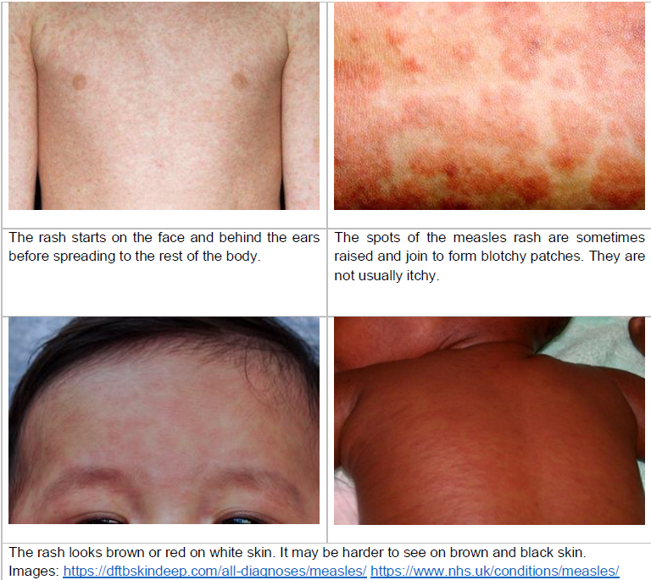Measles can make you:

* feel hot
* have a runny or blocked nose
* sneeze
* cough
* 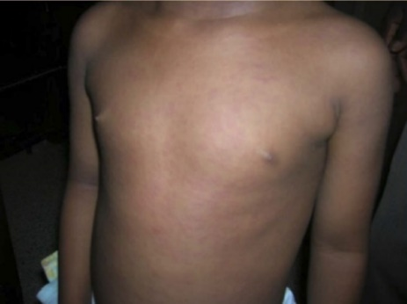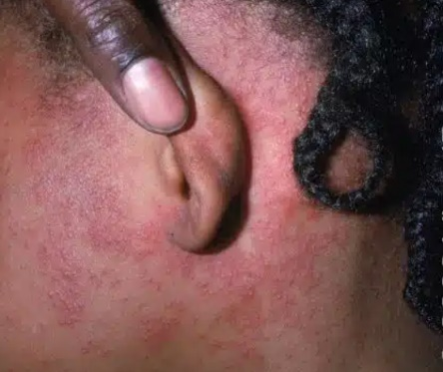have red, sore, watery eyes.

A rash may also appear it starts on the face and behind the ears then spreads over the body.

The rash looks brown or red and can feel bumpy.

Measles can make you very ill and you may need hospital care to help you get better.

**Vaccines**

Vaccines are a type of medicine that we have when we are well, to stop us becoming ill.

There are many vaccines used for different illnesses.

In the UK we give the MMR vaccine which protects against Measles, Mumps and Rubella infection.

The measles virus can make us very unwell, sometimes needing hospital care. Having the MMR vaccine protects us from becoming ill.

Vaccines contain water, weakened parts of the virus and substances that make the vaccine effective.

The MMR vaccine does not contain mercury.

There are two different types of MMR vaccine available in the UK. Vaccines are made with many different ingredients. These help the vaccine work. Some vaccines are made using pork gelatine in very small amounts. The Priorix MMR vaccine does not contain pork gelatine.

After you are given a vaccine, you may feel hot and have body aches. These feelings are caused by the vaccine and are normal. They will stop after a day or so.

**Getting the MMR vaccine**

The NHS doctors would like you to have the MMR vaccine, because it will stop you becoming unwell with measles.

**The MMR vaccine can be given by both doctors and nurses, there will be a team of doctors and nurses coming to your accommodation to give the vaccines in the next few weeks.**

**The doctors may ask you to give a small finger prick blood sample or a spit sample. This will be tested to ensure you are well enough to receive the vaccine. These samples will be thrown away once tested.**

**If you would like to have the MMR vaccine, to stop you becoming unwell,** **please let housing staff know.**

**If you have any questions, please let housing staff know.**

Yours sincerely,

Dr Robyn Dewis (Derby City Director of Public Health)

Eleanor Houlston (Derbyshire Director of Public Health)