# New Arrivals – Home Energy in the UK

How you power and heat your home and pay for it will probably be different from where you lived previously.

Some homes have an electricity and gas supply. Some only have electricity.

When you move into your new home, you need to find out if you have a gas supply as well as electricity and what kind of meters you have.

If you have a gas-powered cooker and metal radiators with pipes, you probably have a gas supply.

Figure A Gas cooker

Figure A radiator

## Meters

Meters measure how much gas and/or electricity you use. There are two types of meters. Pre-payment meters have a card or key you add credit too at a shop. Standard meters are used when you pay for your energy via a direct debit or online payment.

These meters may be in a box on the side of your home or inside your home.

Your home may also have a smart meter display unit. This shows energy costs and usage.

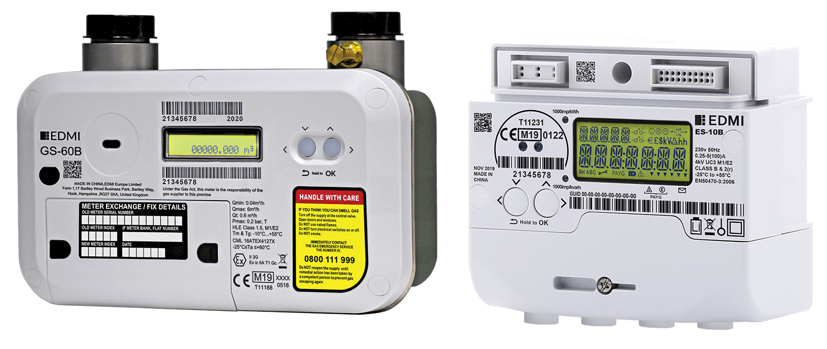

Figure Gas meter (left) and electricity meter (right) Image from Smart Meter Assets.

Figure Smart Meter Display

## Energy suppliers

There are lots of energy suppliers in the UK. Some have lower prices (tariffs). Use an online comparison tool to see which is cheapest.

Some offer fixed price tariffs – this means that the amount you pay for each unit of gas or electricity won’t change during the fixed price period. The overall amount you pay could change depending on how much energy you use. Using less energy will cost less.

When you move into your home, contact the current supplier to tell them you have moved in.

If you don’t know who the supplier is, you can find out using the [steps on the ofgem website](https://www.ofgem.gov.uk/information-consumers/energy-advice-households/finding-your-energy-supplier-or-network-operator#:~:text=Find%20a%20gas%20or%20electricity,and%20your%20gas%20supply%20number).

When you have chosen a supplier, let them know you want them to supply your energy. They will set up an account for you and contact the current supplier.

More information about switching energy supplier is on the [ofgem website](https://www.ofgem.gov.uk/information-consumers/energy-advice-households/switching-energy-supplier).

## How to reduce energy usage

Reducing energy use reduces cost.

### Lighting

Turn off lights when you don’t need them

Use LED lightbulbs. When buying bulbs, look for the lowest wattage or ‘W’ number on the package.

### Appliances

Apart from the fridge and freezer, try to turn off all other appliances at the wall plug when they’re not being used.

If buying new appliances, try to buy A rated or above.

### Washing machine

Only wash a full load and set the temperature to 30°c or below. Use a short or ‘eco’ cycle.

A heated airer is much cheaper than a tumble dryer for drying clothes.

Avoid drying clothes on radiators - it can make the room damp, causing mould and stop the radiators working properly.

Never hang wet clothes on a storage heater or electric heater.

### Fridges/freezers

Ensure there is 5cm of space around the sides, top and back of the fridge and freezer.

Occasionally, pull the fridge out, unplug it and clean the coils.

Fridges should be between 3°c and 5°c. Your freezer should be -18°c.

## Heating

Tips for heating your home:

* Homes should be between 18°c and 21°c.
* If your home has a thermostat, use it to set the temperature so the home doesn’t overheat, costing more.
* Set heating to be on at specific times. Usually, an hour or two in the morning and a few hours in the evening.
* Keep windows and curtains closed when the heating is on to keep heat in.

### Gas Central Heating

* If the radiators have thermostatic valves, use these to lower the temperature of radiators in rooms that get too warm, instead of opening windows.
* In rooms that are too cold, use the thermostatic valves to increase the temperature.
* If your radiators don’t have thermostatic valves, see if you can get these installed.
* Check the flow temperature on the boiler. It should be 60°c. There is more information at moneysavingboilerchallenge.com.
* Add foil behind radiators that are on external walls.

### Electric heating and heaters

**Electric heaters**

* Only use them in rooms that are occupied.
* Do not leave plug in heaters unattended, as they can get very hot.
* Electric heating can be more expensive because electricity costs more than gas.
* If you’re worried about the cost of heating your home with electric heating, use an electric blanket to heat yourself, rather than the room.

**Storage heaters**

Storage heaters work by storing heat at night (when electricity is cheaper) and releasing it during the day to keep your home warm.

You can usually control how much heat is stored and how quickly it is released.

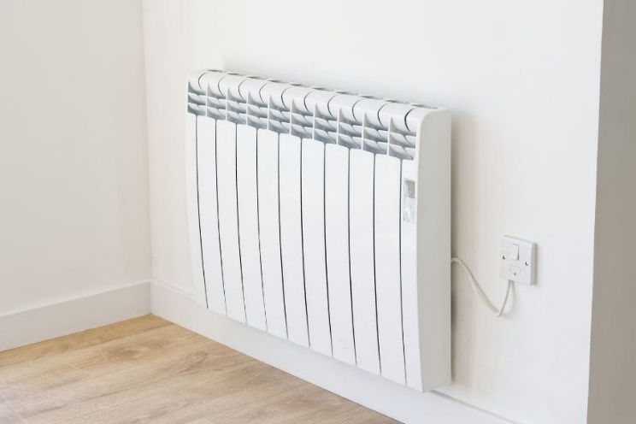

Figure Storage Heater - Energy Saving Trust

## Cooling

To keep your home cooler in summer:

* Keep windows and curtains closed during the day.
* Open windows at night and use a fan by the window to pull in cooler air.
* Only use fans below 35c. Above this, it can make you feel hotter.
* Set the fan to blow over a bowl of cold water and ice. This will blow cooled air around the room.
* Don’t leave fans unattended.

## Energy debt

Emergency Top-up vouchers for those on pre-payment meters in Derby are provided by:

* Groundwork Green Doctor - Call 01159788212 or email [greendoctor@groundworknottingham.org.uk](mailto:greendoctor@groundworknottingham.org.uk)
* Marches Energy Agency - Call 0800 677 1332 or email [wdd@mea.org.uk](mailto:wdd@mea.org.uk)
* National Energy Foundation - Call 01908 665555 or email [info@nef.org.uk](mailto:info@nef.org.uk)
* Welfare Reform Team – [welfare.reform@derby.gov.uk](mailto:welfare.reform@derby.gov.uk)

Those on standard billing who are in debt can get support from some energy suppliers:

* [British Gas Energy Trust](https://www.britishgas.co.uk/energy/help-with-bills/british-gas-energy-trust.html) (for anyone)
* [E.ON Next Energy Fund](https://www.eonnextenergyfund.com/) (for customers)
* [EDF Customer support fund](https://www.edfenergy.com/help-support/faq/get-help-our-customer-support-fund) (for customers)
* [Octopus Assist](https://octopus.energy/blog/bill-support/#help-from-octopus) (for customers)
* [Scottish Power Hardship fund](https://www.scottishpower.co.uk/support-centre/help-paying-your-bill/hardship-fund) (for customers)
* [Ovo customer support package](https://www.ovoenergy.com/extra-support) (for customers)