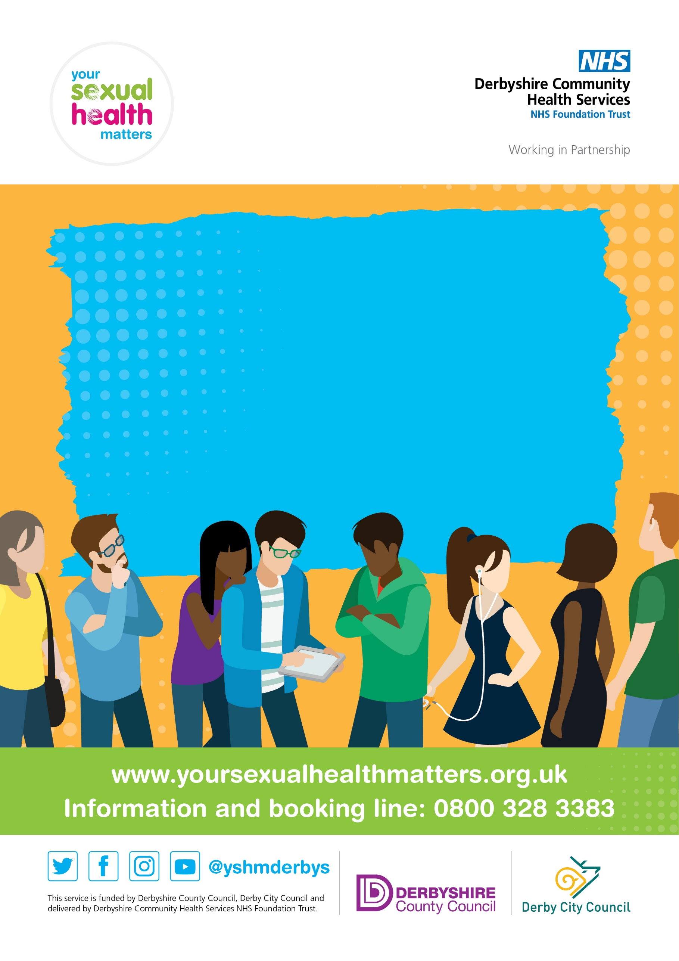

**Find us at: [Midlands &City station hotel on:**

**7 Jan;4 Feb;4 March;9 April;6 May; 10 June;8 July;5 August; 8 Sept;7 Oct;4 Nov and 9 Dec, 2025**

**Sexual Health Promotion pop up clinic 2025 from 12.00 noon- 15 pm**

* **Free, instant STI screenings**
* **Instant testing for HIV and syphilis**
* **Stock up on free condoms**
* **Contraception, emergency contraception and pregnancy testing**
* **Come and meet your amazing sexual health team!**