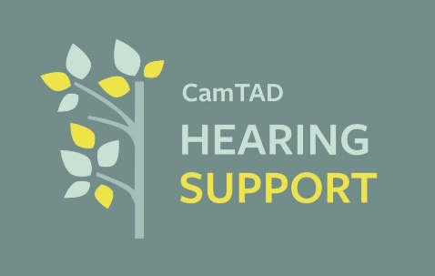

**Job Title:** Charity Coordinator (Part-Time)  
**Hours:** 22.5 hours per week (3 days, flexible working pattern)  
**Contract:** Fixed-term, 1 year  
**Salary:** £17,550.00 per annum (equivalent to £15 per hour)  
**Location:** CamTAD Hearing Support Charity Office (based at Florence Nightingale Community Hospital Derby) (but not employed by NHS)

**About Us**

We are a small, Derby based dedicated, established charity, working to improve the lives of adults with hearing loss. Through community events, information, and practical support we aim to reduce isolation, raise awareness and promote inclusion for people who are hard of hearing.

**Role Overview**

We are looking for a motivated and well-organised Coordinator to support the running of our charity. This role is central to ensuring that our activities, events, and fundraising efforts are successful, helping us to reach and support more people with hearing loss. Working alongside our trustees, volunteers, and community partners, you will take responsibility for administration connected to this post, event planning, and community engagement.

**Key Responsibilities**

* Plan, coordinate, and deliver fundraising events and community activities, with a focus on engaging adults with hearing loss. Within Derby City only.
* Provide administrative support, including record-keeping, managing correspondence, and supporting trustee meetings.
* Support volunteer recruitment, training, and coordination.
* Manage social media channels, newsletters, and publicity materials to raise awareness of hearing loss and promote our work.
* Assist to maintain and update databases of service users, donors, and partners.
* Assist with fundraising efforts, including grant applications, donor communications, and sponsorship opportunities.
* Act as the main point of contact for enquiries, ensuring a welcoming and supportive response for people with hearing loss and their families.
* Support financial administration such as processing invoices and tracking expenses.

**Person Specification**

**Essential**

* Strong organisational and time-management skills.
* Excellent communication skills, both written and verbal, with sensitivity to the needs of people with hearing loss.
* Confident with IT, including Microsoft Office and social media platforms.
* Ability to work independently and manage varied tasks.
* A flexible and positive approach to work.
* Experience in event coordination, administration, or a similar role.

**Desirable**

* Knowledge or lived experience of hearing loss and its impact.
* Experience working in the charity or voluntary sector.
* Understanding of accessibility and inclusion issues for people with hearing loss.
* Experience supporting volunteers and/or fundraising activities.
* Be a vehicle owner/have the use of to enable you to attend events/meetings independently. (Expenses available).

**Benefits**

* Flexible working hours (3 days per week, with occasional evenings/weekends for events).
* Opportunity to make a real difference to the lives of adults with hearing loss.
* Supportive environment and opportunities for professional development.
* Free parking facilities when in the office.

**Due to the nature of this work (working with vulnerable adults) the successful applicant will be asked for 2 references and be subjected to DBS checks.**

